Warning – Park Aid – CGEA1.3

Functional Description

The purpose of the Park Aid Warnings are to inform the driver that the Park Aid System needs to be checked.

The PA_Warn_Flg is defined in the Park Aid Control Function section of this SPSS.

Interface

Interface Context Diagram (I/O Block Diagram)
Figure 1 Warning – Park Aid Context Diagram
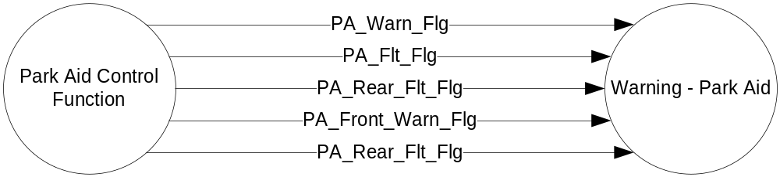

Inputs

- PA_Warn_Flg.
- PA_Front_Warn_Flg
- PA_Flt_Flg
- PA_Front_Flt_Flg
- PA_Rear_Flt_Flg

See the Park Aid Control function with SETUP section of this SPSS for definition of the state of these flags.

Outputs
- Warning Message W345, W346, W347, W350, W351 and W352
For definition of W345, W346, W347, W350, W351 W352, see the Text Message List section of this SPSS.

Function/Performance

Operational Description

Warning Message W345* shall be Active whenever PA_Warn_Flg = Active
Warning Message W345 shall be Inactive whenever PA_Warn_Flg= Inactive.
*NOTE: W345 is legacy. Use of W346 is preferred on Rear only Park Aid, and mandatory on vehicles with both Front and Rear Park Aid.

Warning Message W346 shall be Active whenever PA_Warn_Flg = Active
Warning Message W346 shall be Inactive whenever PA_Warn_Flg= Inactive.
Warning Message W347 shall be Active whenever PA_Front_Warn_Flg = Active
Warning Message W347 shall be Inactive whenever PA_Warn_Front_Flg= Inactive.

Warning Message W350 shall be Active whenever PA_Flt_Flg = Active
Warning Message W350 shall be Inactive whenever PA_Flt_Flg = Inactive
Warning Message W351 shall be Active whenever PA_Rear_Flt_Flg = Active
Warning Message W351 shall be Incative whenever PA_Rear_Flt_Flg = Inactive
Warning Message W352 shall be Active whenever PA_Front_Flt_Flg = Active
Warning Message W352 shall be Incative whenever PA_Front_Flt_Flg = Inactive

For definition of how the Message Center arbitrates and displays Active warnings, see the Warning / Alert Display Logic Diagram, located in the Message Center – X Display with W Button Interface section of this SPSS (where X and W are appropriate values in this document).

Table 1 System Check Function for Park Aid Warning
PA_Flt_Flg | PA_Rear_Flt_Flg | PA_Front_Flt_Flg | Mc SYSTEM CHECK Message ID
INACTIVE | INACTIVE | INACTIVE | Skip to next function
INACTIVE | INACTIVE | ACTIVE | W352
INACTIVE | ACTIVE | INACTIVE | W351
X | ACTIVE | ACTIVE | W350
ACTIVE | X | X | W350

SPSS Module Revision History

Revision Level | Name | Change Description | Date
1.0 | V. Patel | No updates needed for CGEA1.3. Based on CGEA Warning - Park Aid STSS V1.0 | 5/11/2010

